

**DEPARTMENT OF COMPUTER SCIENCE**

**MUSANZE CAMPUS**

**COLLEGE OF SCIENCE AND TECHNOLOGY**

**SCHOOL OF ICT**

**PROJECT REPORT:**

**eGARBAGE MANAGEMENT SYSTEM ANDROID APPLICATION**

**Submitted by:**  
***KABANDA Derrick:*** ***219006351***

***NIGAMAKWANDI Yves:*** ***219006848***

***RUBIBI Paul:*** ***219011925***

*Under the Guidance of*

**MR. NGABO Desire**

Submitted in partial fulfillment of the requirements for the award of   
**BACHELOR OF SCIENCE DEGREE IN INFORMATION SECURITY**.

**January 2023**

# **CERTIFICATION**

*This is to certify that the Project Work entitled,* **“eGARBAGE MANAGEMENT SYSTEM ANDROID APPLICATION”** *is a record of the original bona fide work done by* **Mr. *KABANDA Derrick Reg. No 219006351*, Mr. *NIGAMAKWANDI Yves Reg. No* 219006848, Mr. *RUBIBI Paul Reg. No* 219011925** *in partial fulfillment of the requirement for the award of Bachelor Degree in Computer science with an option of information security in University of Rwanda, college of science and technology during the Academic Year 2021-2022.*

Supervisor **Mr. NGABO Desire**

Signature: Date: --/--/2023

Head of Department of Computer Science Dr. Alfred UWITONZE

Signature……………………Date: ……. /……./……..

# **DECLARATION**

We do hereby declare that the project work " **eGARBAGE MANAGEMENT SYSTEM ANDROID APPLICATION** "submitted in partial fulfillment of the requirements for the bachelor degree in computer science with options information security conducted under the guidance of **Mr. NGABO Desire**, is the record of our own work and has never been presented or submitted for any academic award in any University or Institution as a whole or in part.

Declared By

***KABANDA Derrick ………......................................................***

***NIGAMAKWANDI Yves ..........................................................***

***RUBIBI Paul ……....................................................................***

University of Rwanda -CST

*Date……. /………/…….. And Signature…………………………*

# **DEDICATION**

We dedicate this work to:

* The Almighty God,
* Our families,
* Our friends and colleagues,
* Rwanda National Police,
* University of Rwanda,
* Our Lecturers,
* Our supervisor

# **ABSTRACT**

Waste management has been one of the major environmental problems, where most of the cases people leave uncollated garbage from bins without notice, resulting in overflowing garbage and expelling the area around the trash cans. This has a negative impact on society's health since it is a primary factor in the growth of germs, insects, and vermin. This raises the likelihood of humans contracting them can cause different diseases, and different pollution like air pollution. Rwanda is a developing country that is expanding with amazing creativities, applying smart concepts and technology, developing a smart lifestyle, and constructing smart cities. As a result, we also contributing to smart cities concept by addressing waste management in a strategic manner.

The existing garbage collection system involves regular garbage trucks making daily or weekly rounds, which not only do not cover every zone of the city but are also a waste of government resources. The suggested system, in which the administrator manages the trash app for complete online monitoring and analysis of the system. This paper demonstrates a cost-effective mobile and web-based system for the government to use existing resources to efficiently handle the massive volumes of rubbish collected each day, while also providing a better answer for individuals' difficulty with garbage disposal. With the help of the driver app, it gives information about the garbage ready to be collected and guided routes to the trashes. Then the driver updates from the app for each collected garbage.

**TABLE OF CONTENT**

CERTIFICATION I

DECLARATION II

DEDICATION III

ABSTRACT IV

LIST OF FIGURES VII

LIST OF ABBREVIATIONS IX

CHAP I: GENERAL INTRODUCTION 1

**1.1** **Introduction** 1

**1.2** **Problem Statement** 1

**1.3** **Objective of the Project** 2

**1.3.1 General objectives** 2

**1.3.2 Specific objectives** 2

**1.4** **Scope and Limitations** 2

**1.5** **Security of Project** 3

**1.6 Organization of the report** 3

**1.7 Project Gantt chart** 4

CHAP II: LITERATURE REVIEW 5

**2.1** **Definition of Terminologies** 5

**2.1.1 Garbage:** 5

**2.2** **Existing System** 5

**2.2.1 Disadvantages** 6

**2.3** **Proposed System** 6

**2.3.1 Advantages** 7

CHAP III: RESEARCH METHODOLOGY 8

**3.1** **Introduction** 8

**3.2** **Methodological Approach** 8

**3.2.1** **Observation method** 8

**3.2.2**  **Interviews and Focus Group method** 8

**3.3** **Software Development Model** 9

**3.3.1** **Waterfall Used** 9

**3.4 Design of the New System** 10

**3.4.1 Use Case diagram** 10

**3.4.2** **Sequence Diagram** 12

**3.5 System Requirements** 14

**3.5.1 Technologies & Programming languages** 14

**3.5.2 Hardware requirements** 14

**3.5.3 software requirements and development tools** 15

CHAP 4: ANALYSING, DESIGN, AND IMPLEMENTATION OF THE PROJECT 16

**4.1 Introduction** 16

**4.2 System Analysis** 16

**4.3 Working Principle of the System** 16

**4.3.1 System Modules:** 16

**4.4 Database diagram** 19

**4.5 System Implementation** 20

**4.5.1 Overview of system interface for user’s android mobile application** 20

**4.5.2 Overview of system interface for driver’s android mobile application** 27

**4.5.3 Overview of system interface for admin website dashboard** 31

CHAP V: CONCLUSION & RECOMMENDATION 41

**5.1 Conclusion** 41

**5.2 Recommendation** 41

REFERENCES: 42

# **LIST OF FIGURES**

**Figure 1:** Gantt chart 4

**Figure 2:** System 10

**Figure 3:** Use case 10

**Figure 4:** User 11

**Figure 5:** Relationship 11

**Figure 6:** Use case diagram 11

**Figure 7:** Sequential diagram 14

**Figure 8:** System diagram 18

**Figure 9:** Database Schema diagram 20

**Figure 10:** User - Registration screen 21

**Figure 11:** User - Login screen 22

**Figure 12:** User - Profile screen 23

**Figure 13:** User - Garbage submission screen 24

**Figure 14:** User - Payment screen 25

**Figure 15:** User - Notification alert 26

**Figure 16**: User-transaction history 27

**Figure 17:** Driver - Login screen 28

**Figure 18:** Driver - Dashboard screen 29

**Figure 19:** Driver - Google Map screen 30

**Figure 20:** Driver - Notification alert 31

**Figure 21:** Admin - Login page 32

**Figure 22:** Admin - Dashboard page 33

**Figure 23:** Admin - Driver's list page 33

**Figure 24:** Add/Edit Driver pages 34

**Figure 25:** Admin - Users' list page 35

**Figure 26:** Admin - Trashes's list page 36

**Figure 27:** Add/Edit Trash pages 36

**Figure 28:** Admin - Payments' list page 37

**Figure 29:** Admin - Reports page 38

**Figure 30:** Admin - Analytics page 40

# **LIST OF ABBREVIATIONS**

AES: Advanced Encryption System

IDE: Integrated Development Environment

JDK: Java Development Kit

MD5: Message-Digest algorithm 5

OS: Operation System

OTP: One Time Password

NPC: National Police College

SDK: Software Development Kit

SQL: Structured Query Language

2FA: Two Factor Authentication

# **CHAP I: GENERAL INTRODUCTION**

## **Introduction**

We all know that the "Smart City" concept is being given priority nowadays, therefore we are developing a system which would enhance it. All smart cities combine a variety of portable or web-based solutions to create a pleasant and comfortable human dwelling. One of these plans is to provide an environmentally sound, competent, and appealing waste administration system. Now, the existing situation for garbage/wastage is incompatible if we examine, the current trash collection system integrates routine dump trucks conducting adjustments day by day or week by week, which does not cover every zone of the city and is a completely useless utilization of government assets.

This concept is ideal for saving time and changing the traditional method of trash disposal; thus, this system provides a cost-effective way with an android application and a web-based system for the government to use available resources to efficiently manage the overall amounts of garbage collected on a regular basis, while also providing a better solution for garbage disposal for many cities. Our Location-Based Garbage Management System for Smart Cities app combines the finest approaches for checking and analyzing data obtained in order to deliver the best and easiest routes produced through maps for garbage trucks/vehicles. For the inhabitants, an android application is to created, which effectively makes trash/waste disposal easier.

* 1. **Problem Statement**

With the current system, there is not clear communication between garbage collectors’ agencies and people who have trashes and bins which they want to throw. As a bad result, the rubbishes start to overflow the containers which leads to bad smell and less cleanness of the cites. Also in some cases, people start throwing rubbishes in the unappropriated locations or in the environment which pollute the cities and cause environment pollutions. On the other hand, the garbage collectors’ companies make less profits because of not having real-time information of whether to go to collects trashes, this might reduce their operating hours hence the profit is decreased.

* 1. **Objective of the Project**

The objectives of the project are divided into two categories, general and specific objectives.

### **1.3.1 General objectives**

The general objectives are to:

* Develop a system which will help to achieve smart cities with an effective trash collection system
* Easily connect people, buildings, places with garbage to collect with concerned cleaning agencies

### **1.3.2 Specific objectives**

The project's specific objectives are to:

* Provide a technique will prevent rubbish from overflowing the containers
* Improve environmental quality with bad odors and cleanness cities
* Develop a mobile application which facilitate the payment of trash collection in a secured way
* Develop a system which help drivers who collect trash to easily know where to go for garbage collection
  1. **Scope and Limitations**

During our research, we have focused mainly on improving the existing garbage management system based in our country Rwanda and focusing mainly on most populated regions.

The mobile application to be developed also is only an android based, to mean that our research development will be achieved by the help of android operating system.

The last defined boundary is that during the development of our project, we have implemented mobile money as the type of payment in our system as it is the commonly used way and accessible by everyone to make payments.

* 1. **Security of Project**

To make our system secured, we have enforced different measures for both users and administrator.

* Before saving admins and users’ passwords during the registration process, the system encrypts them by using MD5 hashing as it cannot be decrypted.
* Only registered users can access and using the mobile application to be allowed to submit their reports related to garbage to be collected.
* For the users to proceed with payments, you have to verify and pass the authentication by using fingerprint or password verification.
* For the admins to login into the website dashboard, you they have to complete 2FA (Two Factor Authentication)
* The drivers has access to view only the locations where trashes are available and to confirm the completed locations.

## **1.6 Organization of the report**

This document is composed of 5 chapters, classified as follows:

**Chapter 1**: Provides an overview of the entire project, including the general introduction, background, statement of the problem, choice and motivation of the study, general objective, specific objectives, and scope of the study.

**Chapter 2**: Describes the current system environment, including the processes and analyzing how it works and the problems related to it.

**Chapter 3**: Outlines the methodology used by the researcher to achieve the stated objectives, including the techniques used to collect data, different system analysis, and explanation of the models and technologies used to develop the system.

**Chapter 4**: Presents the implementation of the system, including how it works, expected results, and different diagrams and screenshots.

**Chapter 5**: Gives a conclusion based on the conducted research and the outcomes, and includes recommendations for different parties who could be interested in or benefit from the system.

## **1.7 Project Gantt chart**

**Figure 1:** Gantt chart

# **CHAP II: LITERATURE REVIEW**

* 1. **Definition of Terminologies**

### **Garbage:**

Garbage is human-generated garbage that is thrown owing to a perceived lack of utility. In general, the word excludes bodily waste products, primarily liquid or gaseous wastes, and poisonous waste materials. Garbage is routinely sorted and divided into different types of material that are appropriate for different types of disposals. [1]

* 1. **Existing System**

Every morning, employees arrive at their desks. There are just not enough garbage cans to go around for all of those people. Hundreds of individuals pass the same place on the streets of cities every minute. The apparent solution is for cleaning employees to stay near garbage cans every day until they full up in order to clean them. This is not a viable option. When the garbage cans are continuously full, there are several noticeable negative consequences. One of the most noticeable symptoms is that the surrounding environment begins to smell and become highly unpleasant.

When the garbage cans are full, individuals place their rubbish on the edges of the cans. The garbage collection procedure is crucial for service providers. The conventional method of physically monitoring rubbish in waste bins is a complex, time-consuming procedure that requires more human work, time, and money and is incompatible with modern technology. Irregular waste management, particularly of home, industrial, and environmental garbage, is a root cause of many human issues such as pollution and sickness, and has a negative impact on living creatures' hygiene. [2]

Here are other existing system examples;

**Smart Bins**: Smart bins are equipped with sensors and a communication system that allows them to detect the level of garbage and automatically notify the control center when the bin is full. This helps in reducing overflowing bins and optimizing the routes for garbage collection trucks. Smart bins can be integrated with a mobile application, allowing residents to easily notify the appropriate department about the availability of garbage or overflowing bins. This system can save resources, time and cost by reducing unnecessary rounds of garbage collection trucks, by optimizing the routes of collection, and by reducing the number of overflowing bins and cleaning them.

**RFID-enabled Garbage Management**: RFID technology is used to track and monitor the garbage collection process in real-time. RFID tags are attached to garbage bags or bins, which are then scanned at different stages of the garbage collection process. This system helps in improving transparency and accountability in the waste management process by providing real-time data on garbage collection, including the location and time of collection, and the amount of garbage collected. This system also allows for better analysis and decision-making, by identifying areas that need more frequent garbage collection and improving the overall efficiency of the waste management system.

### **2.2.1 Disadvantages**

* Trucks go and empty containers whether they are full or not, which is time intensive and inefficient.
* Unsanitary environment and appearance of the city
* A bad odor spreads and can cause disease in humans.
* The current approach necessitates a large number of people and is expensive.
  1. **Proposed System**

The proposed system is eGarbage Management system Android Application.

The data related to the number of available trashes of rubbishes will be submitted by users and collected by the application and stored in a database. This data will be processed and displayed on the dashboard that the administrator may analyze using data analytics, reports will be created for admins so that they can decide when to go to collect the trashed in the appropriate time.

Based on the acquired data, garbage vehicles may be provided routes developed by different algorithms and Google Maps API to effectively navigate through all essential waste bins and eventually reach the disposal location.

For the users to submit the reports about their trashes to be collected, they have to fill the form and provide the type and quantity of available garbage, then the application will calculate and prompt to them the amount to pay. And the vehicle will come to pick the trashes after the users have paid and the garbage are full or enough to be collected. Once the trashes are collected, the drivers will update the finished location are the information will be saved in the database.

### **2.3.1 Advantages**

* This technique will prevent rubbish from overflowing the containers.
* The suggested system will minimize the amount of time required for operations.
* Intelligent garbage management in the smart city.
* Garbage collection vehicles are deployed depending on real needs.
* Cost cutting and resource optimization
* Improves environmental quality

- Less odors

- Cleaner cities

* Effective use of garbage vehicles.

# **CHAP III: RESEARCH METHODOLOGY**

## **3.1 Introduction**

In this chapter, we are going to describe in detail on how the research was conducted and what methods used to achieve the objectives. It also describes some techniques used to collect different data and analysis of data collected and explain the technologies and techniques used to develop our system.

## **3.2 Methodological Approach**

It is a specialized data collection and analysis approaches for uncovering new information A research technique is an approach that allows a researcher to map out a systemic procedure to comprehend a phenomenon. Different methodologies must be employed to comprehend an issue or phenomena based on the data available and how relevant the given data is.

In our study we are expecting to use the following data collection methods:

1. Observation

2. Interviews and Focus Groups

### **3.2.1 Observation method**

Observation is a method of acquiring data that involves witnessing behavior, events, or noting physical traits in their natural environment. Observations can be overt. [3]

### **3.2.2 Interviews and Focus Group method**

Interviews and focus groups include chatting face-to-face with subjects about a certain topic or issue. Interviews are usually one-on-one, whereas focus groups are usually made up of multiple people. We were be able to utilize both to collect qualitative and quantitative data.

We have collected input on the current system from people in our target demographic through interviews and focus groups. [4]

## **3.3 Software Development Model**

### **3.3.1 Waterfall Used**

In our project, we chose to use Waterfall model.

For software design and implementation, we used the Waterfall model methodology. This Waterfall Model is composed by 5 phases: Requirement definition, System and Software Design, Implementation and Unit Testing, Integration and System Testing, Operation and Maintenance. (Youssef Shahir, 2011). Each of these Waterfall phases is has to be completely completed before moving to the next phase. Data collection can be gathered from the sources such as the documents, the survey, questionnaires, interviews and observation. This Waterfall model is simple and easy to understand and it is composed by requirement analysis, system design, implementation, system testing, system deployment and system maintenance. In waterfall, development of one phase starts only when the previous phase is complete. Because of this nature, each phase of the waterfall model is quite precise well defined.

**3.3.2 Advantages of Waterfall Model**

* Suitable for small projects
* Easy to use and track
* Well-defined Phases
* When you move to the next phase, you have a clear picture of all previous phases.
* Simple, easy to understand and easy to operate
* Phases are processed and completed individually
* Easy to organize Tasks
* Processes and results are well documented
  + 1. **Disadvantages of Waterfall Model**
* Not suitable for large projects
* Unable to meet changing needs
* You cannot go back to the previous phase.
* Software that works later in the life cycle is not created
* When team members are working on a phase, another team member must wait for the previous phase to complete (no parallelism).

## **3.4 Design of the New System**

### **3.4.1 Use Case diagram**

A Use Case diagram is a graphical representation of a user's potential interactions with a system is called a use case diagram. A use case diagram, which is frequently complemented by other types of diagrams, displays the numerous use cases and user types the system has. Either circles or ellipses are used to depict the use cases.

**Symbols in the Use Case diagram**

**System**

Draw system boundaries using a rectangle that contains system use cases. Place the actor outside the system boundaries.

System

**Figure 2:** System

**Use case**  
Draw use cases using ovals. Label the ovals with verbs that represent the system's functions.

**Figure 3:** Use case

**User**  
 users are the actors of a system. When one system is the actor of another system, label the actor system with the user stereotype.

User

**Figure 4:** User

**Relationships**

Basic symbols and notations for use case diagrams Draw system boundaries using a rectangle that contains system use cases. Place the actor outside the system boundaries. A simple line shows the relationship between users and use cases. Use the arrows marked as either "used" or "extended" to indicate the relationships between use cases. A "use" relationship indicates that one use case is needed for another to perform a task.

Relationship

**Figure 5:** Relationship

***Design of the diagram: Use Case***

**ADMIN**

**DRIVER**

**USER**

**Figure 6:** Use case diagram

### **3.4.2 Sequence Diagram**

The Sequence Diagram model is the collaboration of objects based on a time sequence. That shows how the objects interact with others in a particular scenario of a use case. With the advanced visual modeling capability, you can create complex sequence diagram without an obstacle.

***The elements of sequence diagram***

|  |  |
| --- | --- |
| **Term and definition** | **Symbol** |
| **An actor:**   * It can be a person or system that derives benefit from and is external to the system. * It participates in a sequence by sending or receiving messages. * It is placed across the top of the diagram. |  |
| **An object lifeline:**   * It participates in a sequence by sending or receiving messages. * It is placed across the top of the diagram. |  |
| **An activation**:   * It is a long narrow rectangle placed on top of a lifeline. * It denotes when an object is sending or receive messages |  |
| **A message**:   * It conveys information from one object to another one. * An operation call is labeled with the message being sent and a solid arrow, whereas a return is labeled with the value being returned and shown as a dashed arrow. | : Message sends  : asynchronous  : Message return    : Message call |

**Table 1:** The elements of sequence diagram

This figure explains the sequence of user interaction with a system

**SYSTEM & ADMIN**

**DRIVER**

View reports & Manage drivers

Submit & pay for garbage packages

**USER**

Update picked packages

**Figure 7:** Sequential diagram

## **3.5 System Requirements**

### **3.5.1 Technologies & Programming languages**

* GPS location
* Mobile Money
* Java, XML
* JavaScript
* HTML, CSS
* PHP
* SQL

### **3.5.2 Hardware requirements**

The system hardware required are:

* Computers such as laptops, desktop, android phones
* RAM with 4GB minimum
* Processor: Intel core or i3 of 2.9HZ minimum
* Hard Disk with 500GB minimum

### **3.5.3 software requirements and development tools**

The software required are:

* System type 32 bit or 64bit
* Android studio
* WampServer or XAMPP, MySQL
* VS Code Text editor
* Android SDK
* Java - JDK
* Operating System (OS): Windows 8,8.1,10, or windows 11

# **CHAP 4: ANALYSING, DESIGN, AND IMPLEMENTATION OF THE PROJECT**

## **4.1 Introduction**

Systems analysis is a problem-solving technique that breaks down a system into its components and studies how well those components work and interact to serve their purpose. Systems analysis helps classify each subsystem in the right perspective and context, ensuring that the entire system achieves its goals best with minimal available resources. Create a synchronization between the system and the goal.

## **4.2 System Analysis**

Problem analysis serves as the foundation for the design and development phases of software development. The problem is examined in order to offer enough information to develop a new system. Large issues are subdivided into smaller ones to make them more intelligible and easier to solve. Similarly, in this project, all tasks are subdivided and categorized

## **4.3 Working Principle of the System**

The working principle of the system is that the system is divided in two parts, Android based application for user and website dashboard for admins.

### **4.3.1 System Modules**

**4.3.1.1 Administrator**

For the system administrator, an admin is using a web-based application. To login in the system, the admin must have credentials with administration privileges to be able to enter into the dashboard.

Within the dashboard, an admin can perform several operations explained below:

* Login
* View registered users
* Add allowed locations
* Set the supported type of garbage
* Create Garbage bin
* Update/Delete garbage bin
* Set the pricing per garbage type and location pricing
* Set date for sending vehicles to collect the garbage in case they are enough to be collected
* View list of reported garbage to be collected
* View Garbage Report
* View list of payments

**4.3.1.2 General Users**

For the users, they have the mobile application installed in their smartphones and each user must be registered to start using the application. For the registration you have to provide your personal information like name and phone number, your current location and a strong password to secure your account.

After completing the registration and the login, users are redirected to the home page where they can see a list of supported types of garbage and allowed locations. For users to report that they have garbage in their home or working places, you choose the type of garbage you have and enter the packages. In that case a charging amount will be calculated basing on the entered number of packages. Then user will be redirected to a payment page where you will use your mobile money or credit card or visa card in order to pay. To confirm the payment, you have to be authenticated and verified using fingerprint scanning or to provide the pin.

**4.3.1.3 Drivers**

Drivers have a mobile application with limited access to view the locations where trashes ready to collected are located and they can be able to go there with their vehicles to pick the trashes. And after, the drivers will have to confirm completed locations through the mobile application and it gets updated in the database so that there will be no conflicts in sending multiple drivers at same locations.

**ADMIN Login**

**User Registration**

**& Login**

**2FA / OTP Verification**

**Submit Garbage Form**

**ADMIN Dashboard**

**Proceed to Payment**

**Database**

**Verify Fingerprint Authentication or Password**

**Create & Manage trash bins**

**Confirm and Submit**

**Manage picking date**

**Drivers update picked packages**

**Drivers view all locations with trashes**

**Figure 8:** System diagram

### **4.4 Database diagram**

A database schema is a collection of metadata that describes the relationships between objects and information in a database. An easy way to envision a schema is to think of it as a box that holds tables, stored procedures, views, and related data assets. A schema defines the infrastructure of this box.

***Symbols for Database diagram***

|  |  |
| --- | --- |
| An entity is an object or concept about which you want to store information. |  |
| **Cardinality** specifies how many instances of an entity relate to one instance of another entity. While cardinality specifies the occurrences of a relationship. |  |
| **Connecting line**: One to one solid line that connect attributes to show the relationships of entities in the diagram. |  |
| **Attribute** is a piece of information which determines the properties of a field or tag in a database or a string of characters in a display. |  |
| **Relationships** are associations between or among entities. |  |

**Table 2:** Symbols for Database diagram

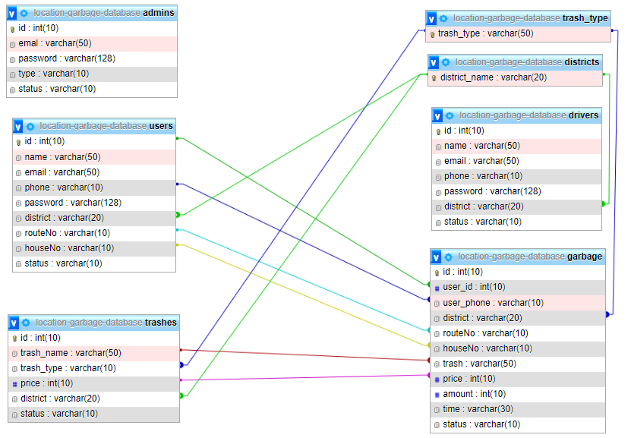

**Figure 9:** Database Schema diagram

## **4.5 System Implementation**

### **4.5.1 Overview of system interface for user’s android mobile application**

The interfaces to be demonstrated are implemented in the android mobile application of the user, which is used by the users to submit reports of garbage to be collected and to make payment for those packages of garbage.

**User - Registration screen**

For users to access the android application, they have to be registered with an email and a password and then provide their basic information like the location address and the house number.

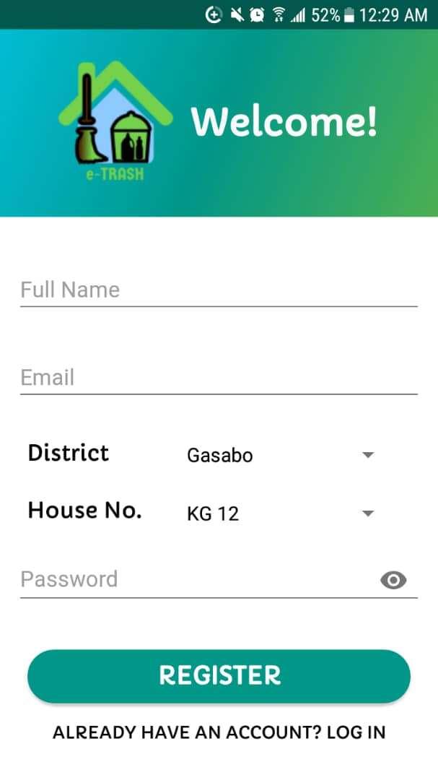

**Figure 10:** User - Registration screen

**User - Login screen**

After registration, a user can login in the application by entering a valid email and password. In case of forgetting a password, the application sends a reset password link to the registered email of the user.

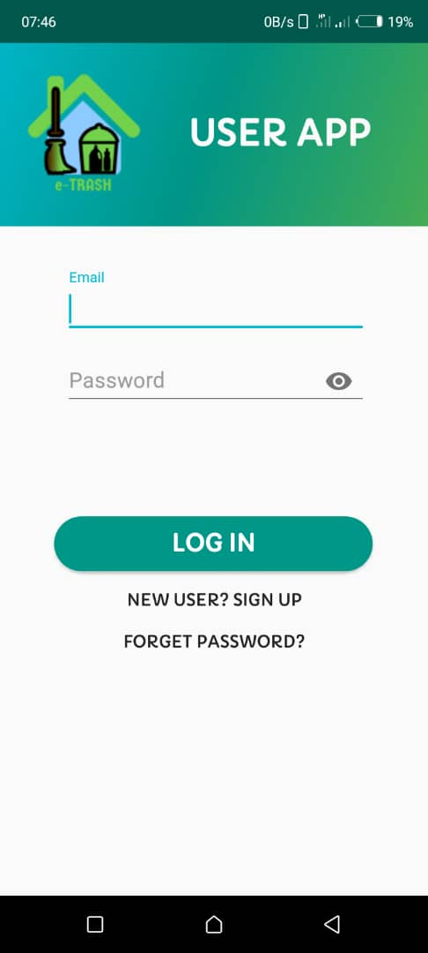

**Figure 11:** User - Login screen

**User – Profile screen**

Once users are logged in the application, they can modify their information like phone number, location address or the house number in case they have relocated in another place so that the information in the system are kept accurate.

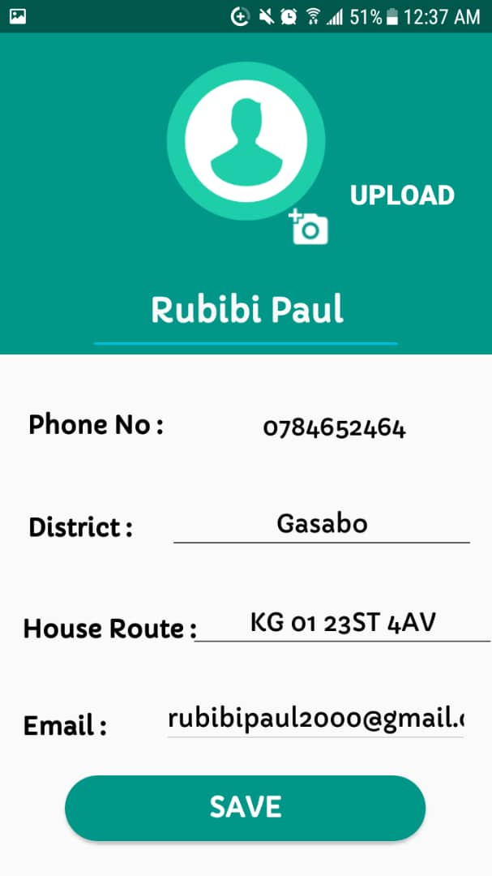

**Figure 12:** User - Profile screen

**User - Garbage submission screen**

This provide a form which is only accessible by approved users. And with this form the users can submit information about the garbage they want to be picked. The users select the type of trash, and put the number of packages and automatically the amount to pay is calculated.

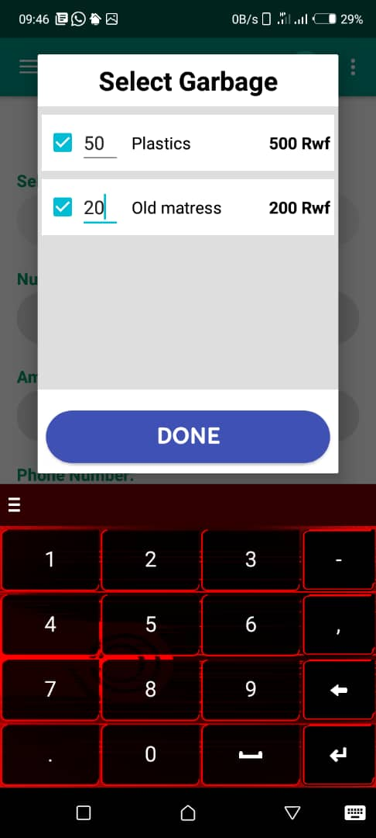 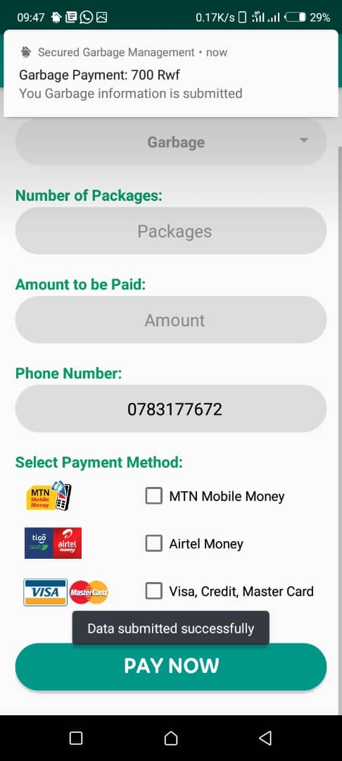

**Figure 13:** User - Garbage submission screen

**User - Payment screen**

This is the screen where users confirm their payment of the amount specified by the application depending on the type of trash and the number of packages to submit. Then user must confirm the security authentication by fingerprint or pin.

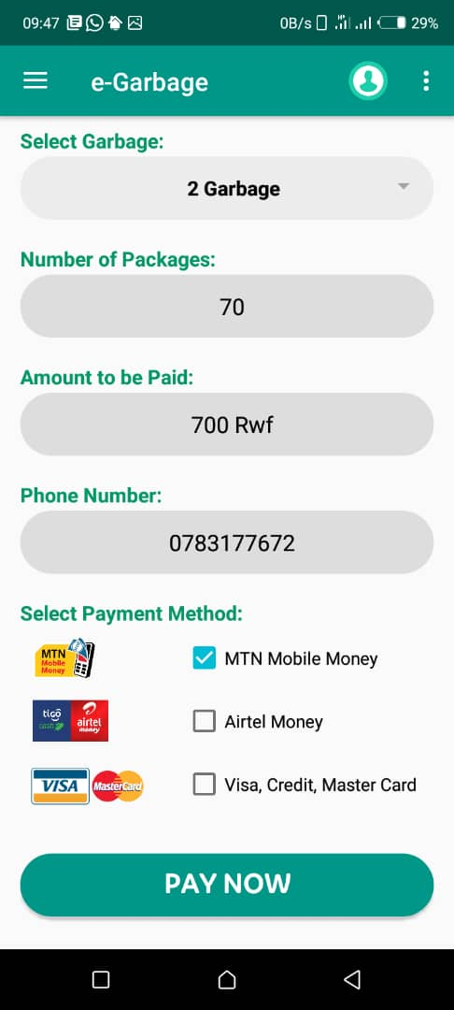 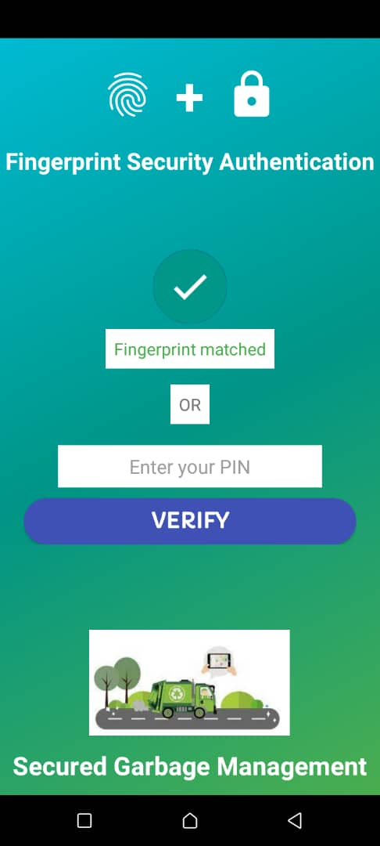

They payment can be done through mobile money and by using credit cards or visa cards.

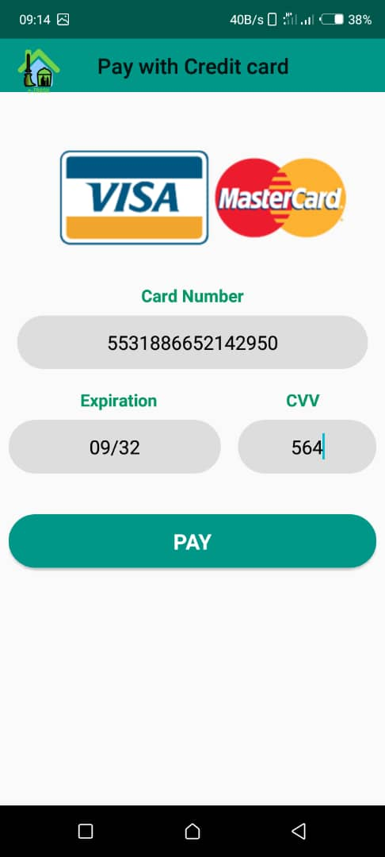 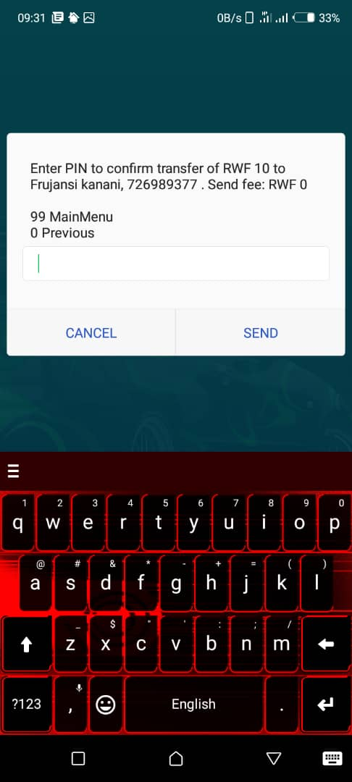

**Figure 14:** User - Payment screen

**User – Notification alert**

The application sends different notifications alerts to the users to inform them about different activities like to notify them that they packages have been submitted, confirming their payment or informing that their packages have been picked.

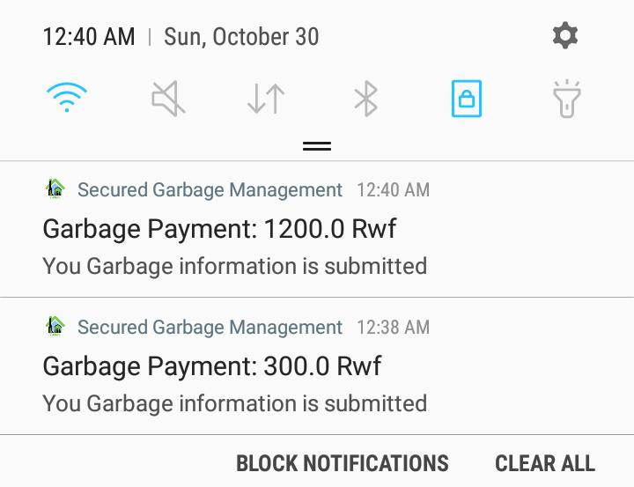

**Figure 15:** User - Notification alert

**User – Transaction history**

On this intuitive and user-friendly screen, users can easily view a comprehensive list of all their past transactions. The list displays not just the names of the items purchased, like garbage or packages, but also their quantities, the total amount paid, and the date of payment. This feature allows users to easily keep track of their financial transactions and ensures transparency in their spending.

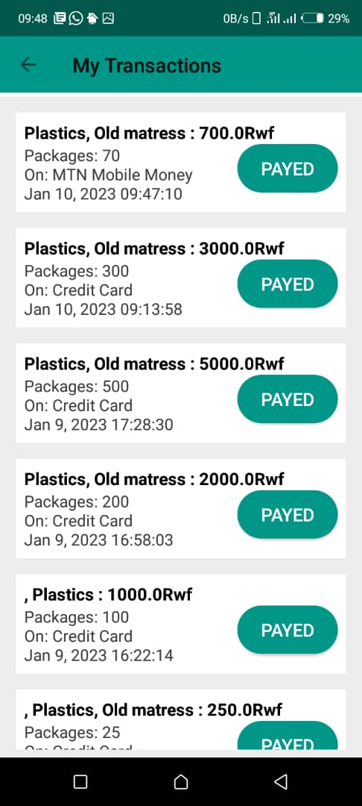

**Figure 16**: User-transaction history

### **4.5.2 Overview of system interface for driver’s android mobile application**

The interfaces to be demonstrated are implemented in the android mobile application of the driver, which is used by the driver to view the list of garbage packages to be collected and to easily locate them on GPS using the Google map.

**Driver - Login screen**

This is the screen which is used the driver to be authenticated before accessing the driver application. The drivers provide their registered email and password with an option to reset the password in case is forgotten.

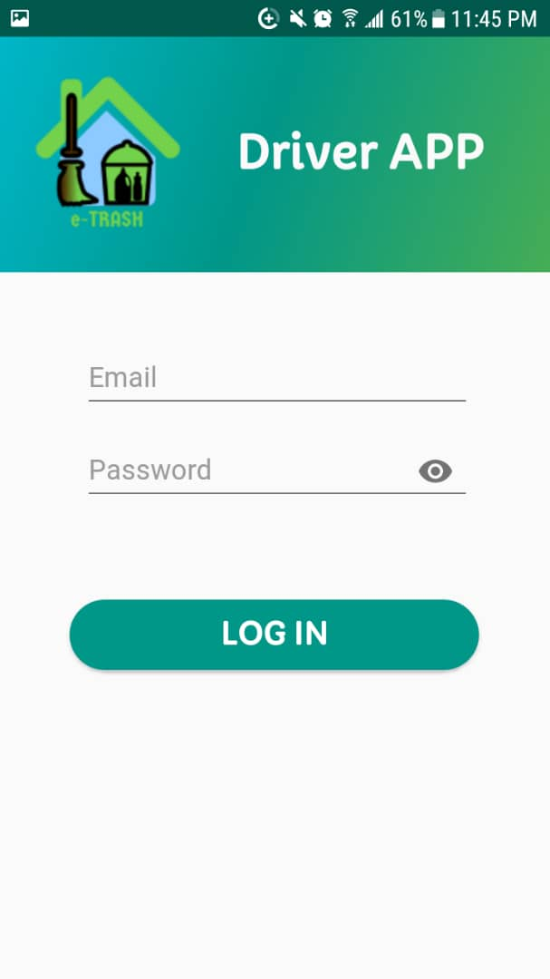 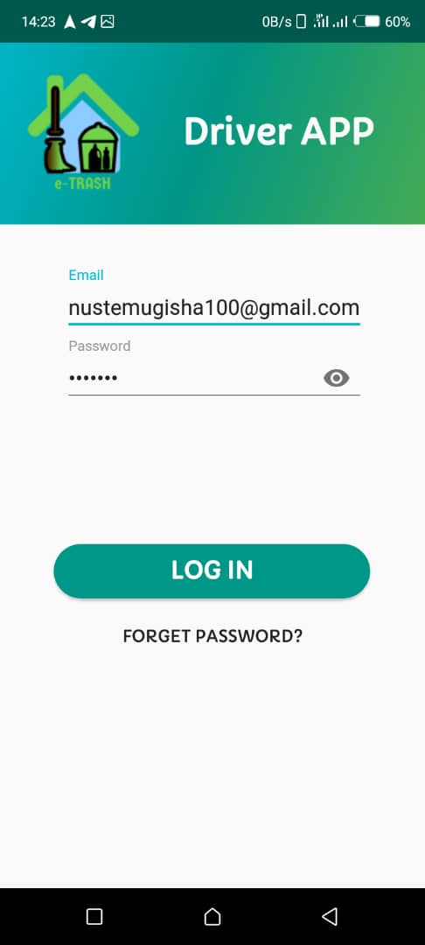

**Figure 17:** Driver - Login screen

**Driver - Dashboard screen**

The driver dashboard screen gives to the approved drivers the possibilities to view a list of packages to be picked alongside all information about each package with an option to view on Google map and confirm picked packages. The drivers can see only data within his location.

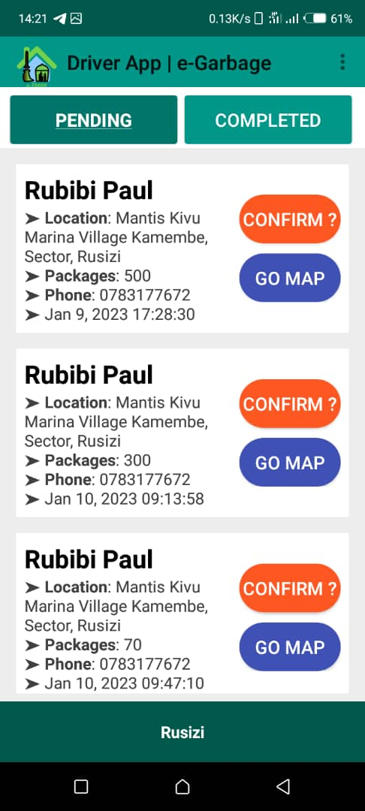

**Figure 18:** Driver - Dashboard screen

**Driver – Google Map screen**

Drivers have an option to view the exact location of the packages on Google map to easily located them with an accuracy in order to don’t waste time instead of moving around different streets looking up for packages which might be even not there.

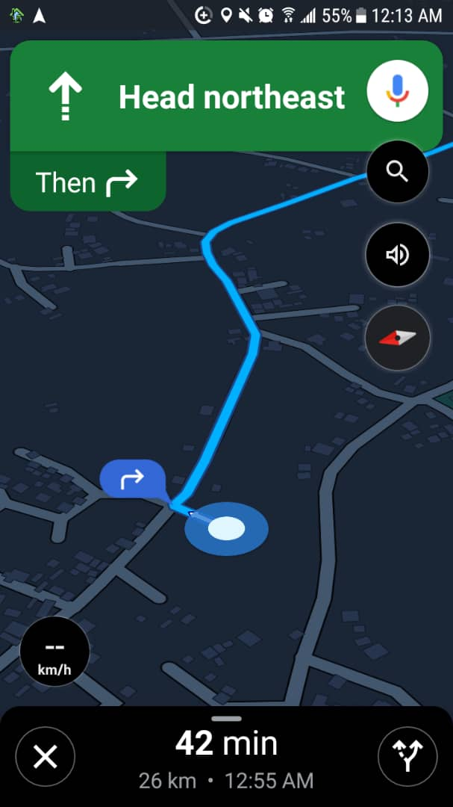 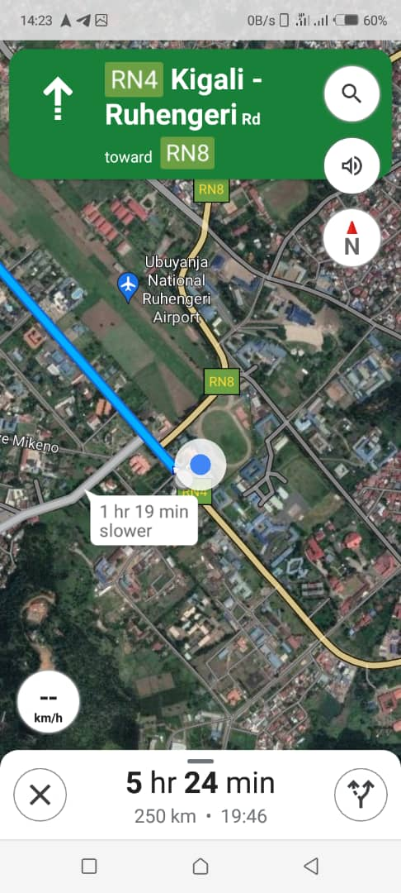

**Figure 19:** Driver - Google Map screen

**Driver – Notification alert**

The drivers quickly receive a notification once new packages are submitted and paid to be picked. This helps the drivers to be alerted on time in order to have a well-planned day for their activities.

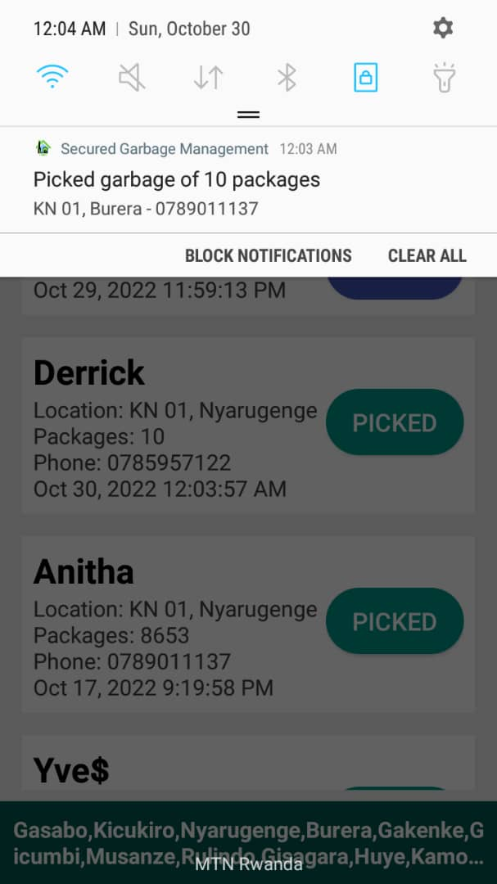 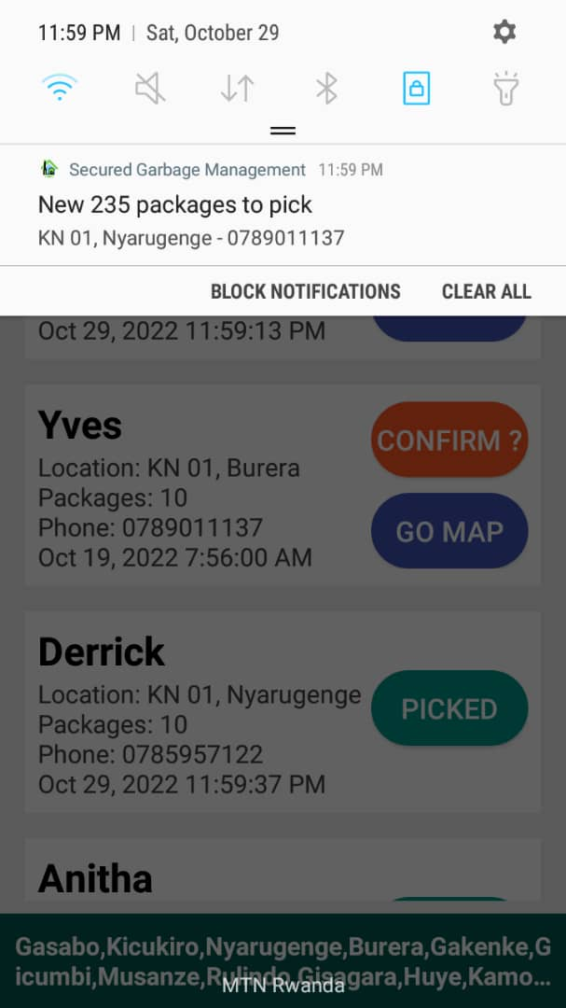

**Figure 20:** Driver - Notification alert

### **4.5.3 Overview of system interface for admin website dashboard**

The interfaces to be demonstrated are implemented in the dashboard website of the admin, which is used by the admin to control the whole system by viewing all data within the system and to validate and grant access to users and drivers.

**Admin - Login page**

The login page is the first page which is shown before entering the dashboard where the system admins have to enter their valid email account and a password. If there entered account matches with the registered account, the system checks if the email account has right for administrator and if yes, it takes the admin to the dashboard. There is also an option to reset the password in case an admin forgets his password.

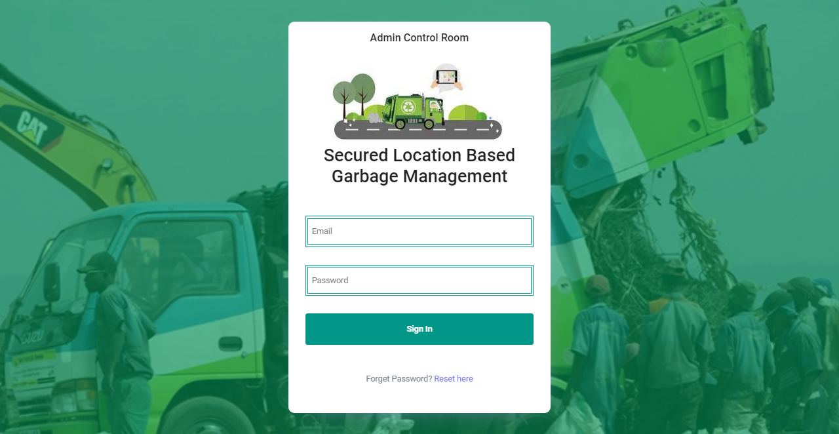

**Figure 21:** Admin - Login page

**Admin - Dashboard page**

This is the dashboard page which gives a clear view of the overall information in the system in form of statistical numbers like the number of users, drivers, trashes, packages in total and per each location. It has also a navigation to other section of the website.

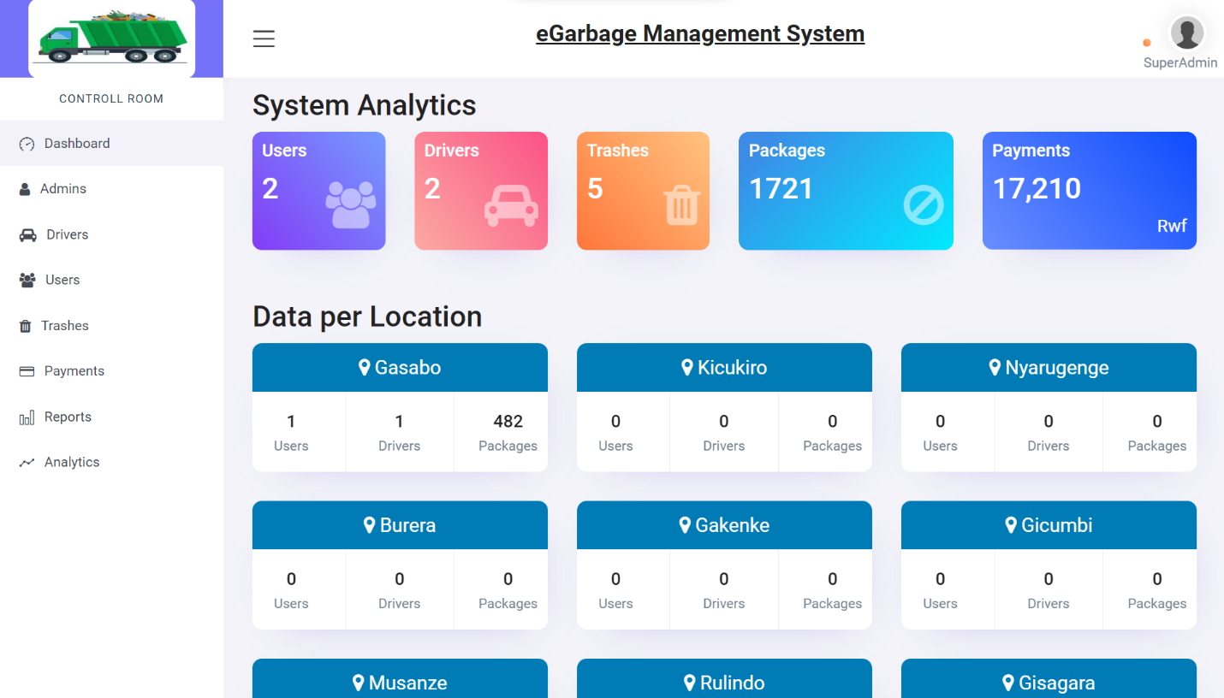

The admin can only access data related to their specific location, including information on users, trashes, payments, and more.

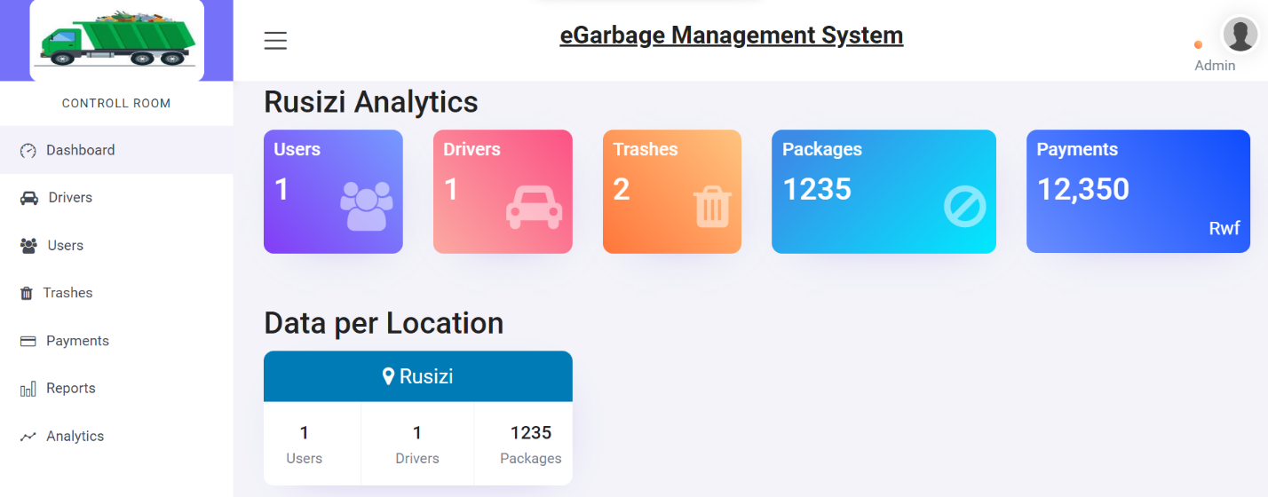

**Figure 22:** Admin - Dashboard page

**Admin – Drivers’ list page**

This is the page which list all registered drivers in the system by showing all necessary information about each driver like the name, email, phone number and the location within where they work. The listing gives also some option to approve a driver, or the edit information of a driver.

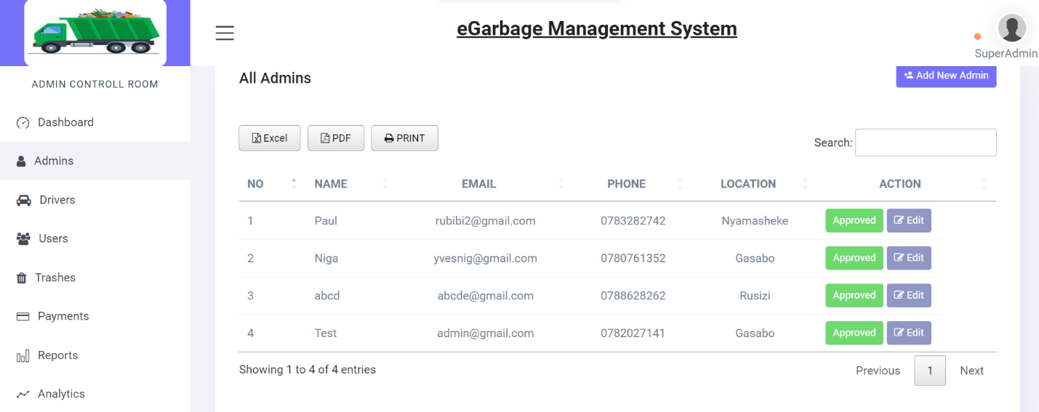

**Figure 23:** Admin - Driver's list page

**Admin – Add/Edit Driver page**

This is the registration form for the drivers where the admin can register a driver by providing driver name, phone, email, location as district(s) and default password. Then a change password link is sent to the registered driver’s email to be able to change to the desired unique password. With this form also, the admin can modify driver’s information excluding the email and the password.

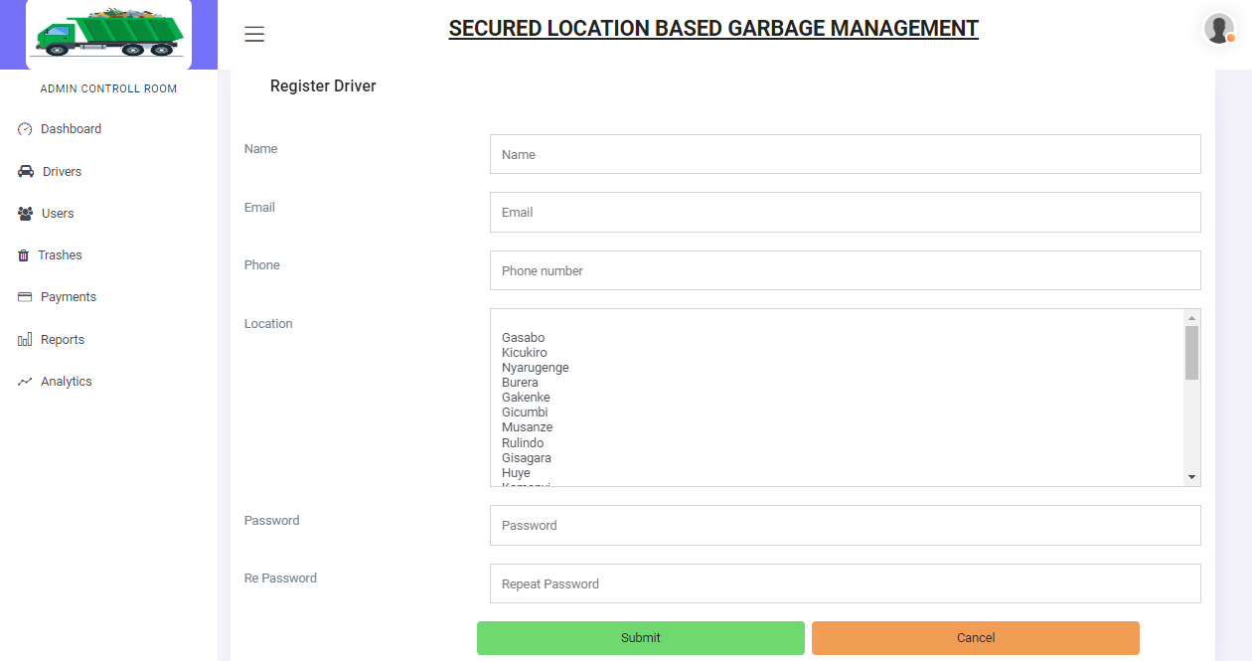

**Figure 24:** Add/Edit Driver pages

**Admin – Users’ list page**

This is the page which list all registered users in the system in a form of table. It shows user photo, name, phone number location and house number. It also gives the admin an option to approve a user with right information or to disable any user at any time.

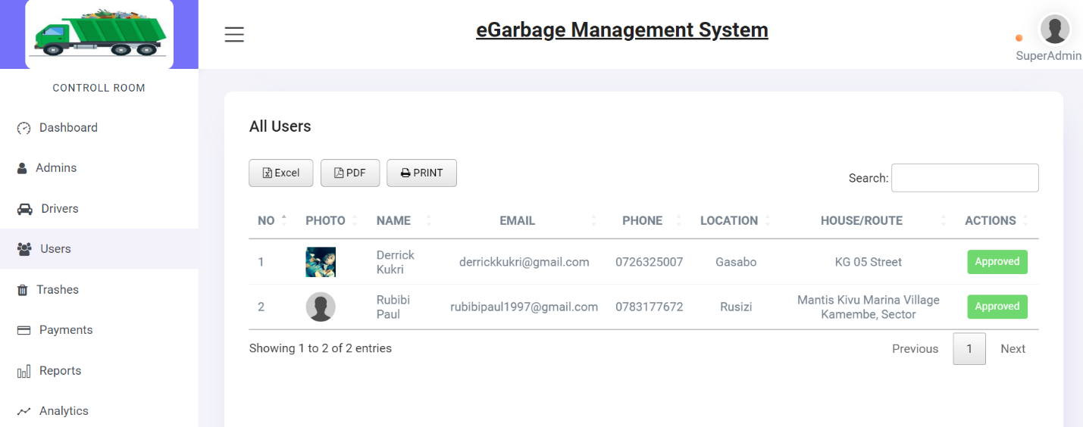

**Figure 25:** Admin - Users' list page

**Admin – Trashes’ list page**

This a page which lists all added types of trashes and it means that there are the only supported types of trashes in the system. The table show the location where each type of trash is support in and the price of each. With an option to delete a trash or modify its information.

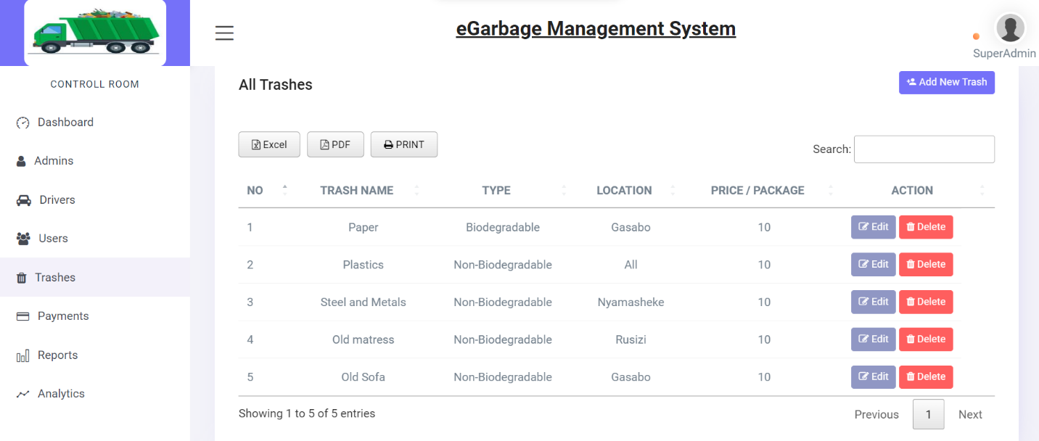

The admin has the ability to access the listing of trash in their designated location and also use it to generate reports and statistics on waste management for their area.

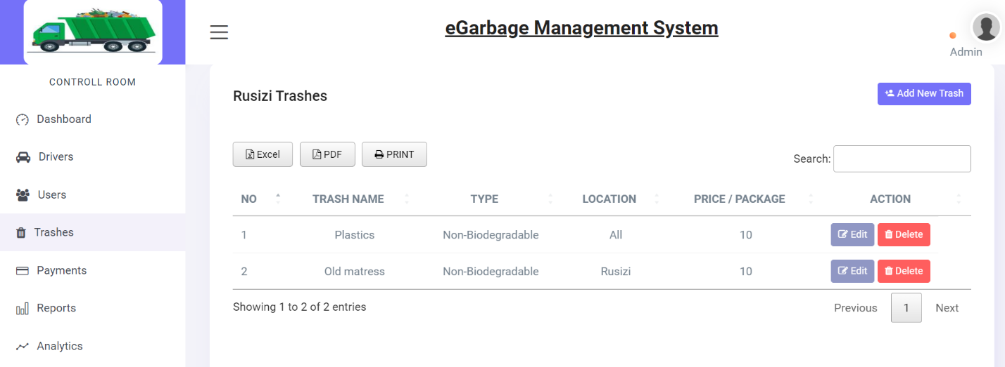

**Figure 26:** Admin - Trashes’ list page

**Admin – Add /Edit Trash pages**

The admin has a place where to add a new supported type of trash by providing the name of the trash, specifying whether the trash is biodegradable or not, setting the price for each package and the location where that type of trash is supported.

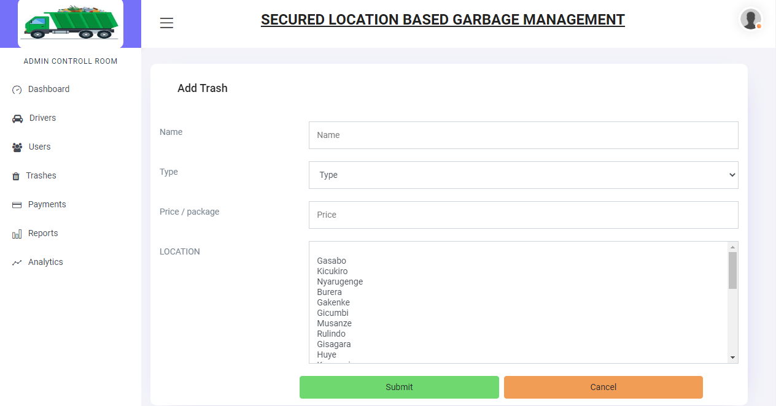

**Figure 27:** Add/Edit Trash pages

**Admin – Payments’ list page**

This a page which list all occurred payments by showing the payer, the type of submitted garbage the number of packages and the total amount to pay and also the payment month used and whether it paid or not yet paid.

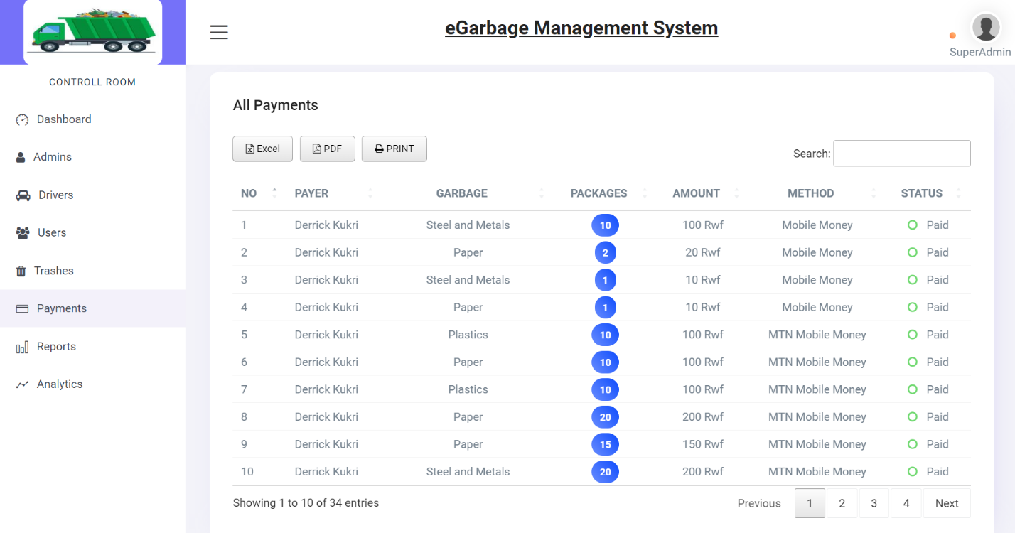

**Figure 28:** Admin - Payments' list page

**Admin – Reports page**

This a page which shows a report of all submitted information, and where a driver pick the garbage he send a confirmation which is also displayed on the report.

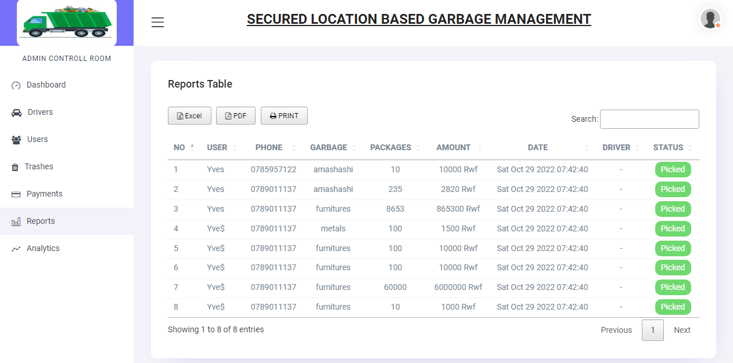

The admin has the ability to view all reports related to their location.

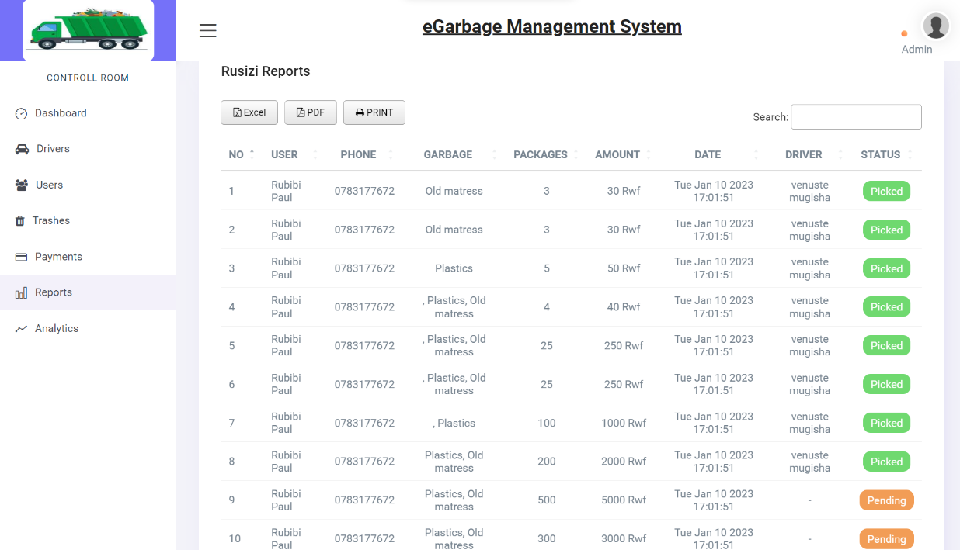

**Figure 29:** Admin - Reports page

**Admin – Analytics page**

The analytics page on the system provides a comprehensive statistical overview to the administrator. It presents a clear and concise visual representation of the data in the system, through the use of various graphical elements such as pie charts and line charts. The pie chart shows the distribution of trash types and their locations, providing a quick and easy way for the administrator to identify areas where certain types of trash are more prevalent, and areas that may need more attention. The submitted packages section presents the number of packages submitted from different locations, which allows the administrator to identify areas with higher participation and areas that may need more outreach. The line chart view presents an overall overview of the system, providing a clear picture of the progress and performance of the system over time. This can be useful in identifying trends and patterns in waste management, as well as identifying areas where improvements are needed. Overall, the analytics page is an essential tool that helps the administrator to make informed decisions and optimize the performance of the system.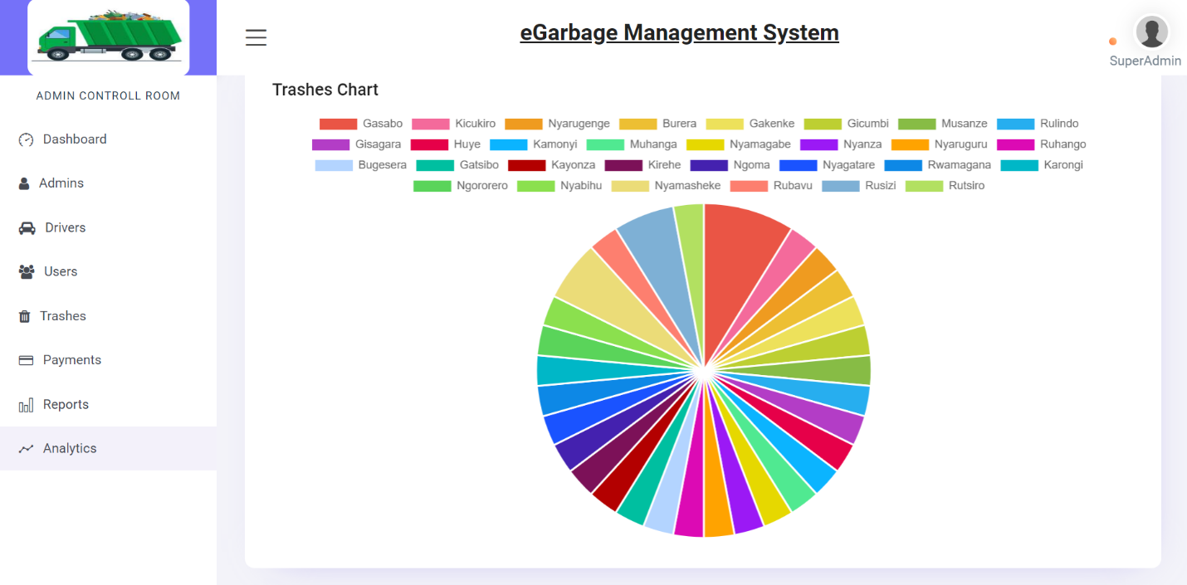

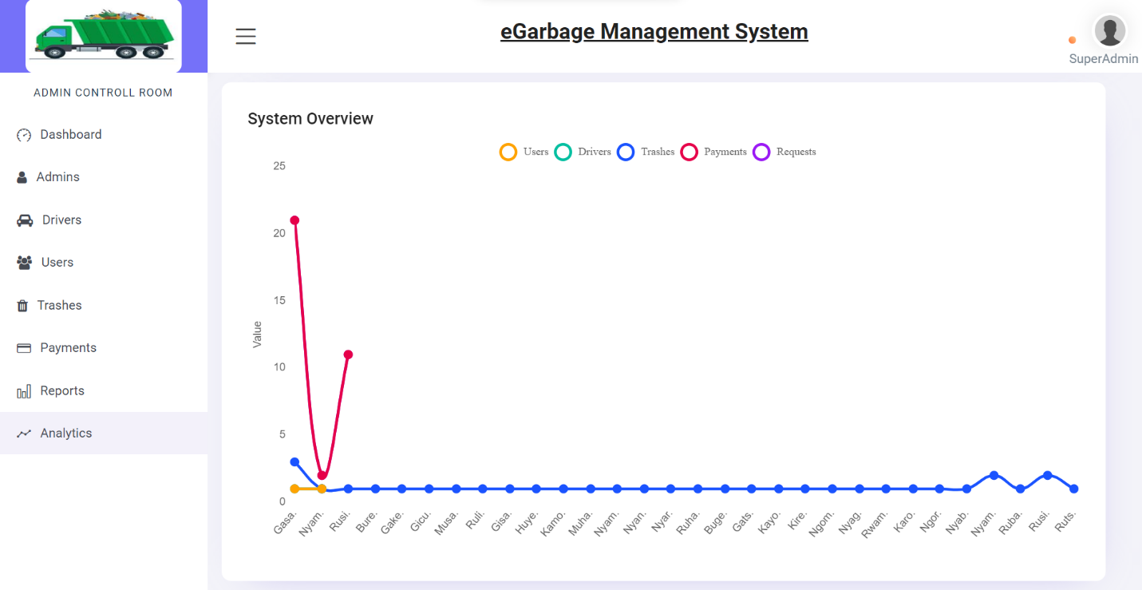

**Figure 30:** Admin - Analytics page

# **CHAP V: CONCLUSION & RECOMMENDATION**

## **5.1 Conclusion**

This research has demonstrated the potential for a new generation of waste management systems to address the challenges of garbage management and environmental pollution. The developed system is designed to be user-friendly and efficient, allowing residents to easily notify the appropriate department about the availability of garbage or overflowing bins through a mobile application. Additionally, the proposed system can save resources, time and cost by reducing unnecessary rounds of garbage collection trucks, by optimizing the routes of collection, and by reducing the number of overflowing bins and cleaning them. It is believed that the system developed and proposed in this research has the potential to significantly improve the overall performance of the garbage management system by reducing environmental pollution and costs associated with waste collection and disposal, while also improving the transparency and accountability of the waste management process.

## **5.2 Recommendation**

It is suggested that further studies should be conducted to explore the integration of sensors in trash bins to detect the level of garbage automatically and alert the control system. This could improve the transparency of the waste management process by allowing real-time data collection for better analysis and decision making. Additionally, integrating sensors in trash bins could also help in identifying areas that need more frequent garbage collection and improve the overall efficiency of the waste management system. With this integration, the system can become more proactive, reducing the number of overflowing bins and environmental pollution. Furthermore, this integration could also allow for more accurate data collection and analysis, which could be used to optimize routes for garbage collection trucks, reduce collection costs and identify trends and patterns in waste management.

# **REFERENCES:**

[1] Susan Strasser, Waste and Want: A Social History of Trash (2014), p. 6-7.

[2] Iraguha, F., Ramelan, A. H., & Setyono, P. (2022, April). Assessment of current solid waste management practices, community perceptions, and contributions in the City of Kigali, Rwanda. In IOP Conference Series: Earth and Environmental Science (Vol. 1016, No. 1, p. 012056). IOP Publishing.

[3] Ciesielska, M., Boström, K. W., & Öhlander, M. (2018). Observation methods. In Qualitative methodologies in organization studies (pp. 33-52). Palgrave Macmillan, Cham.

[4] Wilkinson, S. (1998). Focus group methodology: a review. International journal of social research methodology, 1(3), 181-203.

[5] "Integrated solid waste management: A lifecycle inventory" by W.R. Walker and D.R. Ullman published in the Journal of Cleaner Production in 2011.

[6] "Smart waste management systems: A review of the state-of-the-art" by N. G. Tsagarakis, N. K. Kiousis and K. A. Goulias, published in Waste Management in 2014.

[7] "A review on current status and future prospects of garbage sorting machines" by S. Xing, Y. Chen and S. Wang published in Renewable and Sustainable Energy Reviews in 2018.

[8] "A review of solid waste management practices in Canada" by J.A. Saleh and J.J. Spink published in Journal of "Smart Garbage Management System using Internet of Things (IoT)" by Y. Prabhu and S. Sathya published in International Journal of Engineering Trends and Technology (IJETT) in 2016.

[9] "A Review of Solid Waste Management in Malaysia" by P.K. Ngan, A. Ariffin and N. Ismail published in Waste Management in 2010.

[10] "Design of an integrated solid waste management system" by H.H. Nasr and K.G. Tawfik published in Journal of Environmental Management in 2004.

[11] "Urban Garbage Management with the Internet of Things" by E. López, J. C. Segura, J.J. Merelo, A. Prieto and M. Fernández published in Sensor’s journal in 2016.

[12] "Design and implementation of a web-based monitoring system for garbage collection using radio frequency identification technology" by J.H. Lee and D.S. Lee published in Waste Management in 2010.

[13] "Monitoring of municipal solid waste management: a case study in the city of Bologna" by P. Scarfì, A. Fabbri, F. Lombardi and S. Nocentini published in Journal of Environmental Management in 2009.Environmental Management in 2002.

[14] Ademola, A., & Adepoju, O. (2019). E-waste management in Nigeria: Current status, challenges and future prospects. Journal of Cleaner Production, 213, 1203-1212.

[15] Gizaw, A. (2018). E-waste management in Ethiopia: Status, challenges and future prospects. Waste Management, 74, 255-263.

[16] Osibanjo, O., & Adeboye, O. (2015). E-waste management in Nigeria: Issues and challenges. Journal of Applied Sciences and Environmental Management, 19(3), 735-741.

[17] Oluwafemi, O., & Adebayo, A. (2018). E-waste management in Ghana: Current status, challenges and future prospects. Journal of Cleaner Production, 193, 899-906.

[18] Njenga, M., & Musau, G. (2017). E-waste management in Kenya: Current status, challenges and future prospects. Journal of Cleaner Production, 161, 1282-1291.

[19] Asongu, S. A. (2019). E-waste management and environmental quality: African evidence. Journal of Cleaner Production, 216, 863-874.

[20] Mokhine, M., & Mokhine, M. (2019). E-waste management in South Africa: Current status, challenges and future prospects. Journal of Cleaner Production, 213, 1213-1222.